
Department of Mechanical and Industrial Engineering
Mechanical Engineering
Course Number | MEC713
Course Title | Project Management
Semester/Year | Fall/2023
Professor name | Dr. Sajad Saeedi
T.A name | Feze Golshani Gharie Ali

Assignment No. |  | 1

Submission Date | September 29, 2023
Due Date | September 29, 2023

Student Name | Student ID (xxxx1234) | Signature*
Farris Hamid | xxxx34692 | 
(Note: Remove the first 4 digits from your student ID)
*By signing above you attest that you have contributed to this submission and confirm that all work you have contributed to this submission is your own work. Any suspicion of copying or plagiarism in this work will result in an investigation of Academic Misconduct and may result in a “0” on the work, an “F” in the course, or possibly more severe penalties, as well as a Disciplinary Notice on your academic record under the Student Code of Academic Conduct, which can be found online at: http://www.ryerson.ca/senate/policies/pol60.pdf.

Questions

How can Acorn quickly increase its project management maturity? (20 points)

The case study suggests that there is a lack of project management data. As a result, Acorn should start by spending money on equipment like warehouses that will help with data gathering and processing. An Acorn team of project managers should then select a model to evaluate project management maturity based on studies in the field. One of the best models in the business is the Kerzner one. This would then provide the company with guidance on where to concentrate their efforts. The projects' consistency and control should be established first because this will enable the testing of novel performance-improving strategies.

How should Acorn organize now, considering both their commercial business and their growing government business? (20 points)

For the present term, pure project organization is more suited for the organization. As a result, the new initiatives will be able to function independently, and their success or failure will not have an impact on the profitable commercial company that already exists. A pure project organizational structure would allow for synergy and give a comprehensive picture of the project, since new defense programmes demand more R&D and coordination with production planning. It will make the customer the center of attention, and the project manager will have complete control over the project, which is critical for long-term projects. However, more personnel is required for this method, and resources should be allocated to acquire more technically superior workers.

What should Acorn do about the KMIP incentive program? (20 points)

Given the long-term nature of the new diversified initiatives, the main goals of the KMIP programme should include a futuristic strategy on what to accomplish and how to do it. This ought to encourage cross-departmental cooperation in project estimation and planning. For R&D and production, specific goals must be specified.

As Acorn continues to grow, should it consider adopting a matrix structure? (20 points)

Due to their organizational role, Acorn would need to use a matrix structure. Because marketing is so important in generating proposals, a matrix structure will bring employees and managers from all departments together to work toward a common objective.

Should the functional or project managers be responsible for performance evaluations? How should Acorn handle the positive evaluation bias by PMs? (20 points)

Acorn has produced a great deal of talent. Because the development and expansion took place in such a short period of time, there was insufficient evidence to prove that operations were successful. My own opinion on this topic is that performance assessments should be the responsibility of functional managers. I also feel that the project manager should evaluate their suggestions or come up with assessment points in order to be fair.

Case Study
Acorn Industries, Harold R. Kerzner, PhD Acorn Industries, prior to July of 1996, was a relatively small Midwestern corporation dealing with a single product line. The company dealt solely with commercial contracts and rarely, if ever, considered submitting proposals for government contracts. The corporation at that time functioned under a traditional form of organizational structure, although it did possess a somewhat decentralized managerial philosophy within each division. In 1993, upper management decided that the direction of the company must change. To compete with other manufacturers, the company initiated a strong acquisition program whereby smaller firms were bought out and brought into the organization. The company believed that an intensive acquisition program would solidify future growth and development. Furthermore, due to their reputation for possessing a superior technical product and strong marketing department, the acquisition of other companies would allow them to diversify into other fields, especially within the area of government contracts. However, the company did acknowledge one shortcoming that possibly could hurt their efforts—it had never fully adopted, nor implemented, any form of project management.

In July of 1996, the company was awarded a major defense contract after four years of research and development and intensive competition from a major defense organization. The company once again relied on their superior technological capabilities, combined with strong marketing efforts, to obtain the contract. According to Chris Banks, the current marketing manager at Acorn Industries, the successful proposal for the government contract was submitted solely through the efforts of the marketing division. Acorn’s successful marketing strategy relied on three factors when submitting a proposal:

- Know exactly what the funder wants.
- Know exactly what the market will bear.
- Know exactly what the competition is doing and where they are going.

The contract awarded in July 1996 led to subsequent government contracts and, in fact, eight more were awarded amounting to $80 million each. These contracts were to last anywhere from seven to ten years, taking the company into early 2009 before expiration would occur. Due to their extensive growth, especially with the area of government contracts as they pertained to weapon systems, the company was forced in 1997 to change general managers. The company brought in an individual who had an extensive background in program management and who previously had been heavily involved in research and development.

Problems Facing the General Manager The problems facing the new general manager were numerous. Prior to his arrival, the company was virtually a decentralized manufacturing organization. Each division within the company was somewhat autonomous, and the functional managers operated under a Key Management Incentive Program (KMIP). The prior general manager had left it up to each division manager to do what was required. Performance had been measured against attainment of goals. If the annual objective was met under the KMIP program, each division manager could expect to receive a year-end bonus. These bonuses were computed on a percentage of the manager’s base pay, and were directly correlated to the ability to exceed the annual objective. Accordingly, future planning within each division was somewhat stagnant, and most managers did not concern themselves with any aspect of organizational growth other than what was required by the annual objective. Because the company had previously dealt with a single product line and interacted solely with commercial contractors, little, if any, production planning had occurred. Interactions between research and development and the production engineering departments were virtually nonexistent. Research and Development was either way behind or way ahead of the other departments at any particular time. Due to the effects of the KMIP program, this aspect was likely to continue. Change within the Organizational Structure To compound the aforementioned problems, the general manager faced the unique task of changing corporate philosophy. Previously, corporate management was concerned with a single product with a short-term production cycle. Now, however, the corporation was faced with long term governmental contracts, long cycles, and diversified products. Add to this the fact that the company was almost devoid of any individuals who had operated under any aspect of program management, and the tasks appeared insurmountable. The prime motivating factor for the new general manager during the period from 1997 to 1999 was to retain profitability and maximize return on investment. In order to do this, the general manager decided to maintain the company’s commercial product line, operating it at full capacity. This decision was made because the company was based in solid financial management and the commercial product line had been extremely profitable. According to the general manager, Ken Hawks, The concept of keeping both commercial and government contracts separate was a necessity. The commercial product line was highly competitive and maintained a good market share. If the adventure into weaponry failed, the company could always fall back on the commercial products. At any rate, the company at this time could not solely rely on the success of government contracts, which were due to expire. In 1996, Acorn reorganized its organizational structure and created a program management office under the direct auspices of the general manager (see Exhibit I).

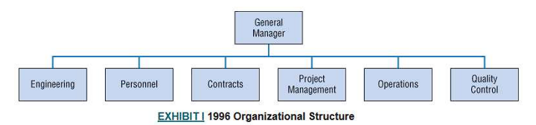
Expansion and Growth In late 1996, Acorn initiated a major expansion and reorganization within its various divisions. In fact, during the period between 1996 and 1997, the government contracts resulted in the acquiring of three new companies and possibly the acquisition of a fourth. As before, the expertise of the marketing department was heavily relied upon. Growth objectives for each division were set by corporate headquarters with the advice and feedback of the division managers. Up to 1996, Acorn’s divisions had not had a program director. The program management functions for all divisions were performed by one program manager whose expertise was entirely within the commercial field. This particular program manager was concerned only with profitability and did not closely interact with the various funders. According to Chris Banks, The program manager’s philosophy was to meet the minimum level of performance required by the contract. To attain this, he required only adequate performance. As Acorn began to become more involved with government contracts, the position remained that given a choice between high technology with low reliability, and vice-versa, the company would always select an acquisition with low technology and high reliability. If we remain somewhere in between, future government contracts should be assured. At the same time, Acorn established a Chicago office headed by a group executive. The office was mainly for monitoring for government contracts. Concurrently, an office was established in Washington to monitor the trends within the Department of Defense and to further act as a lobbyist for government contracts. A position of director of marketing was established to interact with the program office on contract proposals. Prior to 1997, the marketing division had always been responsible for contract proposals. Acorn believed that marketing would always, as in the past, set the tone for the company. However, in 1997, and then again in 1998 (see Exhibits II and III), Acorn underwent further organizational changes. A full-time director of program management was appointed with further subdivisions of project managers responsible for the various government contracts. It was at this time that Acorn realized the necessity of involving the program manager more extensively in contract proposals. One faction within corporate management wanted to keep marketing responsible for contract proposals. Another decided that a combination between the marketing input and the expertise of the program director must be utilized. According to Chris Banks, We began to realize that marketing no longer could exclude other factors within the organization when preparing contract proposals. As project management became a reality, we realized that the program manager must be included in all phases of contract proposals.

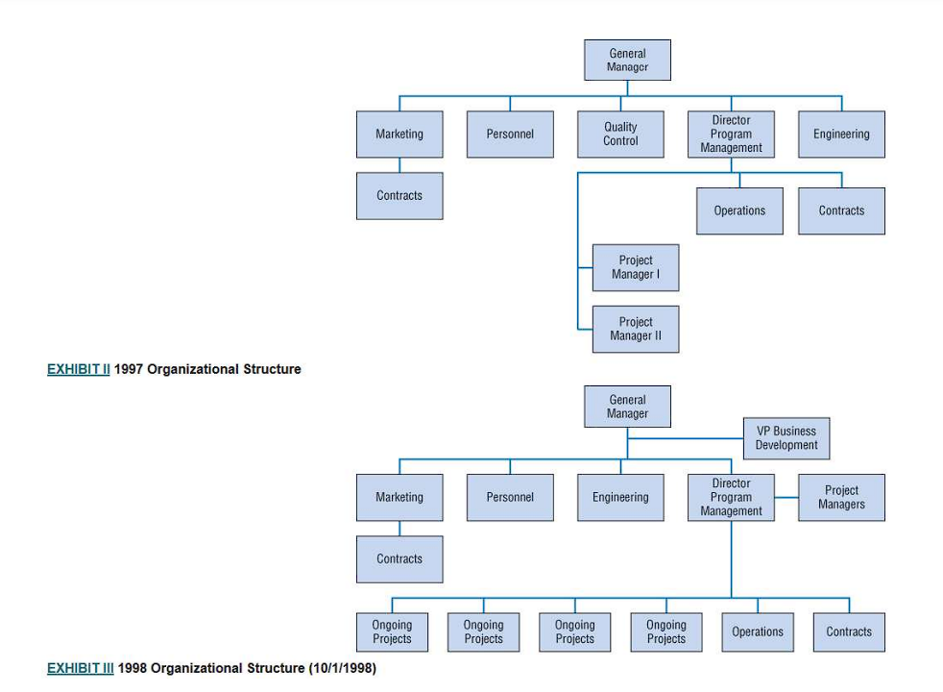
Prior to 1996, the marketing department controlled most aspects of contract proposals. With the establishment of the program office, interface between the marketing department and the program office began to increase.

Responsibilities of the Project Manager
In 1997, Acorn, for the first time, identified a director of program management. This individual reported directly to the general manager and had under his control:
- The project managers
- The operations group
- The contracts group
Under this reorganization, the director of program management, along with the project managers, possessed greater responsibility relative to contract proposals. These new responsibilities included:
- Research and development
- Preparation of contract proposals
- Interaction with marketing on submittal of proposals
- Responsibility for all government contracts
- Trade-off analysis
- Cost analysis
- Interface with engineering department to ensure satisfaction of funder’s desires

Due to the expansion of government contracts, Acorn was now faced with the problem of bringing in new talent to direct ongoing projects. The previous program manager had had considerable power over operations and maintained a singular philosophy. Under his tenure, many bright individuals left Acorn because future growth and career patterns were questionable. Now that the company is diversifying into other product lines, the need for young talent is crucial. Project management is still in the infancy stage. Acorn’s approach to selecting a project manager was dependent upon the size of the contract. If the particular contract was between $2 and $3 billion, the company would go with the most experienced individual. Smaller contracts would be assigned to whoever was available.

Interaction with Functional Departments
Due to the relative newness of project management, little data was available to the company to fully assess whether operations were successful. The project managers were required to negotiate with the functional departments for talent. This aspect has presented some problems due to the long-term cycle of most government contracts. Young talent within the organization saw involvement with projects as an opportunity to move up within the organization. Functional managers, on the other hand, apparently did not want to let go of young talent and were extremely reluctant to lose any form of autonomy.

Performance of individuals assigned to projects was mutually discussed between the project manager and the functional manager. Problems arose, however, due to the length of projects. In some instances, if an individual had been assigned longer to the project manager than to the functional manager, the final evaluation of performance was submitted. In some instances, adequate performance was rated high in order to maintain an individual within the project scheme. According to some project managers, this aspect was a reality that must be faced, due to the shortage of abundant talent.

Current Status
In early 1998, Acorn began to realize that an orders shortage relative to government contracts would possibly occur in late 2001 or early 2003. Acorn initiated a three-pronged attach to fill the apparent void:
- Do what you do best.
- Look for similar product lines.
- Look for products that do not require extensive R&D.

To facilitate these objectives, each division within the corporation established its own separate marketing department. The prime objective was to seek more federal funds through successful contract proposals and utilize these funds to increase investment into R&D. The company had 6 finally realized that the success of the corporation was primarily attributed to the selection of the proper general manager. However, this had been accomplished at the exclusion of proper control over R&D efforts. A more lasting problem still existed, however. Program management was still less developed than in most other corporations.

